**Tell us what your idea is.**

*Describe in 250 words what the feature or service will do and how you’ll use Machine Learning to push the bar:*

*Have you ever had a hard time keeping up with the latest news due to time constraints? Or the newspaper you have is not in your language? Wanted to play games while in a traffic jam or waiting for someone?*

**PocketFeed** is an Android Application designed to help users access any type of articles and paper games in a digitized way. Core features of the application include -

* **Articles** - Add Snapshot of any article you want to read and let the magic begin. You can **read it** or opt for **audio listening**. You can **translate it in your native language** in case you find an article in a different language. Having time issues, no worries! The app would have a feature of **summarizing the news** for you. This makes sure the user experience is equitable for people from various backgrounds.
* **Learn** - PocketFeed holds the capability of **detecting any object, advertisements, offers, alerts** and can **display relevant information** (wiki articles and more) based on what you scanned.
* **Play** - You can **play games** namely, sudoku, crosswords, phrase matching, etc just by taking a snapshot of the game and it would reflect it on your phone which you can easily play anywhere and anytime.

On - Device machine learning fulfills all the requirements of PocketFeed. I plan to use -

* **Google Cloud Vision AI** **API** to extract text from images, detect sudoku and derive insights from any other form of information.
* **Google Cloud Translation API** to convert any article to users’ selected language.
* **Cloud text-to-speech API** to enable audio listening of the articles.
* **Cloud Natural Language API** to display related information and other resources of knowledge based on the image.

**Tell us how you plan on bringing it to life.**

*Describe where your project is, how you could use Google’s help in the endeavor, and how you plan on using On-Device ML technology to bring the concept to life. The best submissions have a great idea combined with a concrete path of where you plan on going, which should include:*

* *(1) any potential sample code you’ve already written,*
* *(2) a list of the ways you could use Google’s help,*
* *(3) as well as a timeline on how you plan on bringing it to life by May 1, 2020.*

PocketFeed is in ideation phase currently. I have created some wireframes to let you get an Idea of how it would look like.

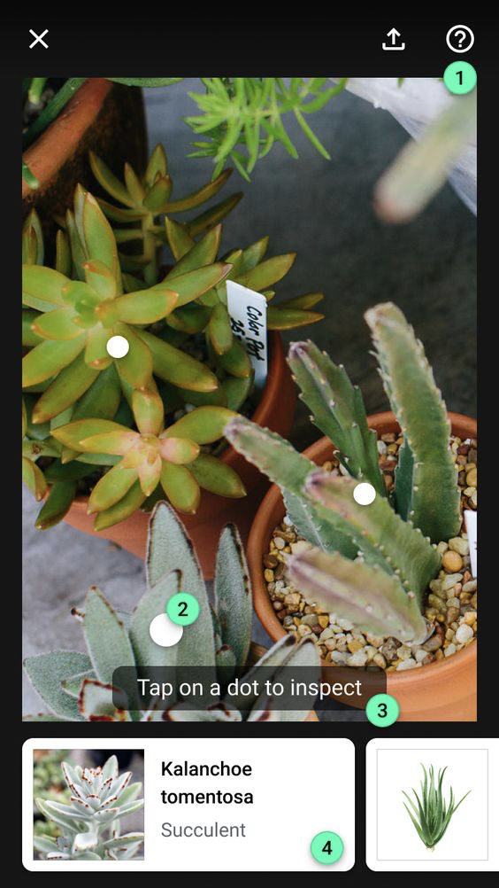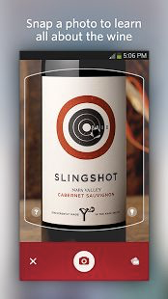  **1. Learn by inspecting any object 2. Snapshot any article or announcement**

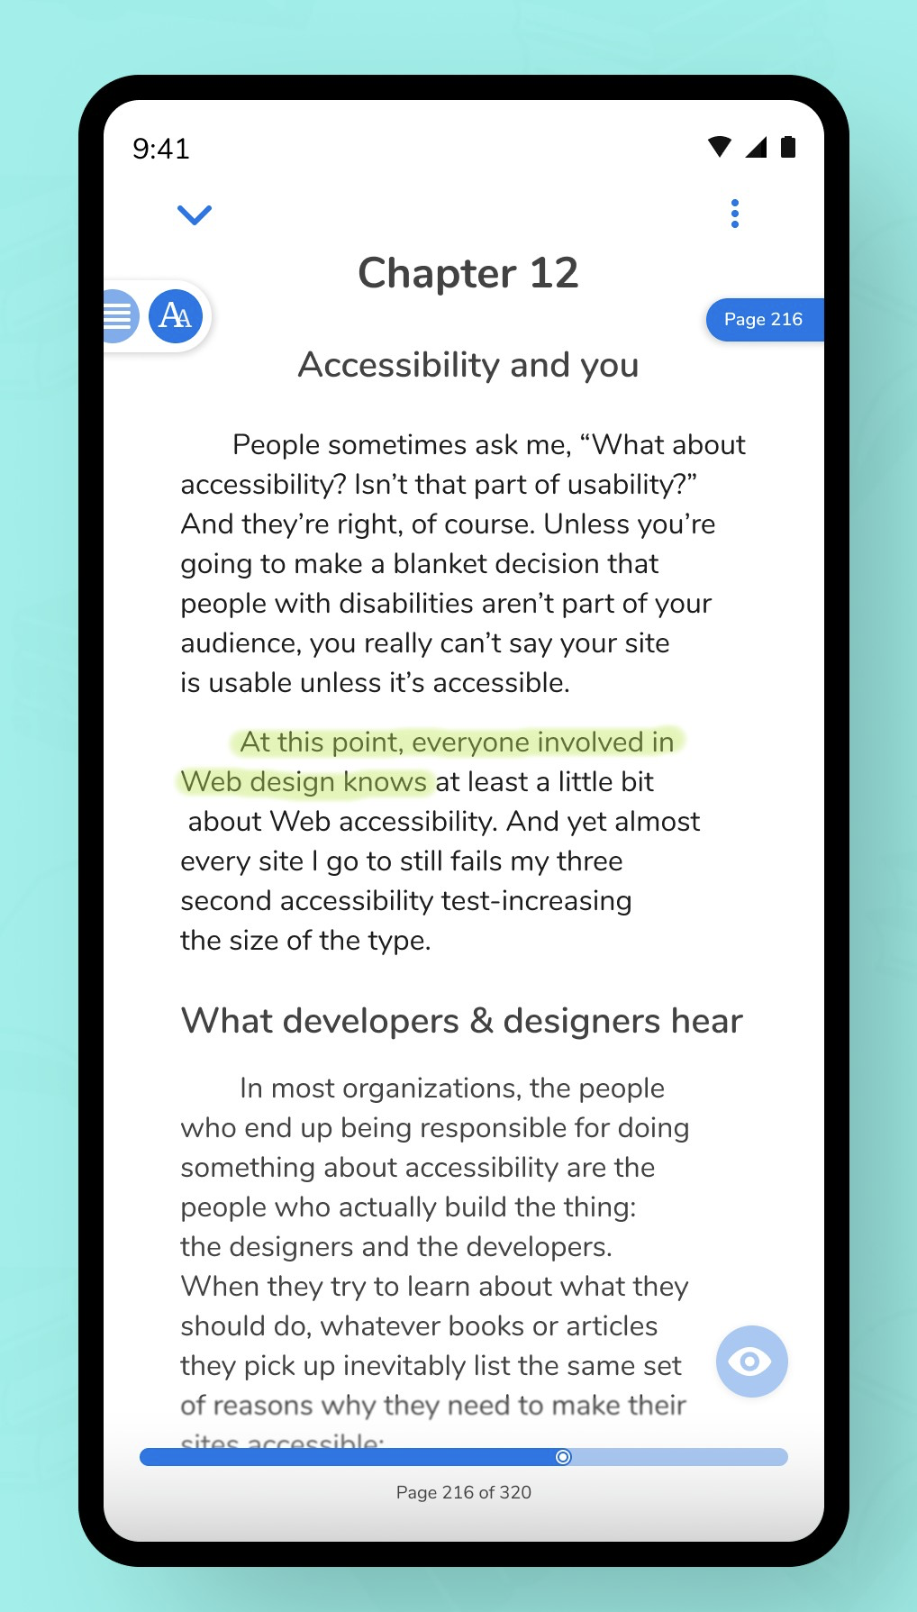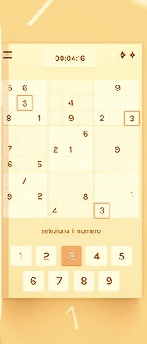

**3. Text Reader, Audio and Summarization 4. Paper Games**

I would require Google’s help for various things -

* Guidance for integrating the pre-built ML algorithm for summary generation of the article in the application.
* Reviewing the current status of the project on a timely basis and let me be familiar with the shortcomings (if any), thereby working on them.
* Help reach a larger audience.
* Suggestions on future works and addition of more features would be highly appreciated.

Proposed Timeline -

* **December, 2019** - Base Setup for the project, Exploring all the APIs, research regarding text summarization and learning.
* **January, 2019** - Completion of Article module which includes UI, integration of Vision AI, Translate, Text to speech and Text summarization algorithm.
* **February, 2019** - Completion of Play Module which includes UI, Gesture recognition and games implementations (validations and scorings)
* **March, 2019** - Completion of Learn module with UI and integration Object detection API. Testing starts this month.
* **April 1, 2019** - Alpha Release
* **April 15, 2019** - Beta Release, debugging and handling crashes if any.
* **May 1, 2019** - App gets published on Play Store.

**Tell us about you.**

A great idea is just one part of the equation; we also want to learn a bit more about you. Share with us some of your other projects so we can get an idea of how we can assist you with your project.

I am Tanvi Goyal, from India. I have graduated from Delhi University with a Bachelor of Science Degree (Computer Science) in May 2019. Currently, I am working as an Android Developer at Embibe, Bangalore - world’s most powerful ed-tech platform, using AI to improve student learning outcomes at scale.

I am a self-taught and outcome-oriented Android Developer. My interest in Android started in 2nd year of my college, and therefore I built an application for my college featuring, attendance marking system, college events, college schedule and much more. Thereafter, I took up various self projects and internships to enhance my skills and learn about best practices in Android.

Being specific, I have worked on Google Firebase, Retrofit, SQLite, ObjectBox, OpenCV, Dagger, Android Architecture Components, Android TV and Android animations. I am well versed with the best practices and tools used for developing scalable and user-friendly android applications.

The Android Developer Challenge took my attention at the Android Dev Summit 2019. I have always been amazed by all the capabilities machine learning brings with it. I aim to use these capabilities to increase the efficiency of my applications and using it to provide some advanced experiences to my users.

Thus I am looking forward to an amazing experience full of learning with The Android Developer Challenge.

**Social Links** -

* LinkedIn - <https://www.linkedin.com/in/goyaltanvi94/>
* Github - <https://github.com/Tanvi-Goyal>
* Gmail - [goyaltanvi94@gmail.com](mailto:goyaltanvi94@gmail.com)
* PortFolio - <https://tanvi-goyal.github.io/>

**Next steps.**

* Be sure to include this cover letter in your GitHub repository
* Your GitHub repository should be tagged #AndroidDevChallenge
* Don’t forget to include other items in your GitHub repository to help us evaluate your submission; you can include prior projects you've worked on, sample code you've already built for this project, or anything else you think could be helpful in evaluating your concept and your ability to build it
* [**The final step is to fill out this form to officially submit your proposal.**](https://docs.google.com/forms/d/e/1FAIpQLSe43koQL33IzgxXQl29Ex3AhFuqd4hQzxLiXREqwRkDGtx1vA/viewform?usp=sf_link)